COMM使用说明

概述
COMM是gamecomm组件的公用层，对于gamecomm的用户来说，这里提供了一些通用的算法。

COMM中的算法

2.1 shtable（Hash表）
其实现原理见下图：

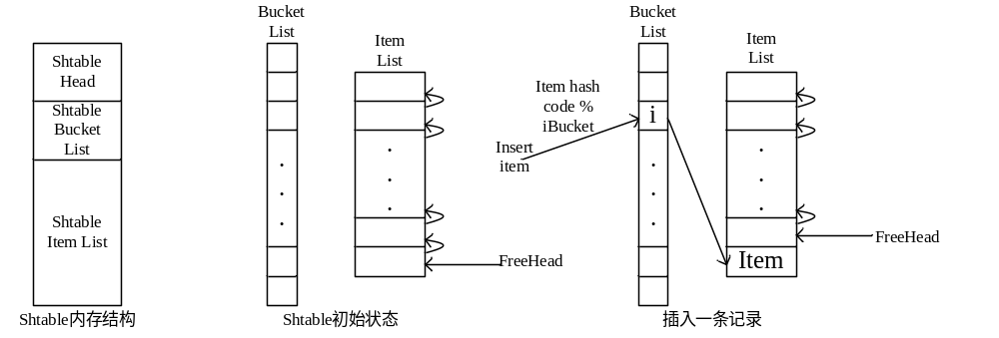

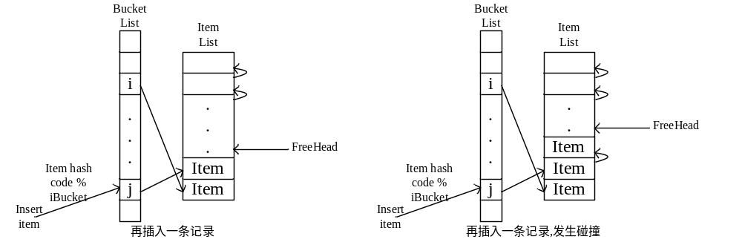
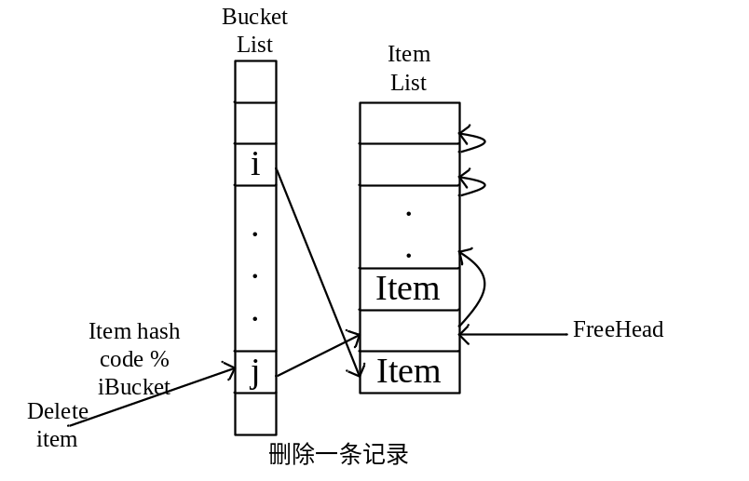

具体接口参见shtable.h中的注释。

使用示例：
#include "comm/shtable.h"

#define MAX_APP_ITEM 1000
#define MAX_APP_BUCKET 5*MAX_APP_ITEM
#define SCAN_NUM_ONE_LOOP 10

typedef struct tagUinShtData
{
long lUin; /*uin of player*/
int iIdx; /*index of player in memory pool*/
}UinShtData;

int UinHashCmp( const void * pv1 , const void *pv2 )
{
UinShtData *pstUinHashData1 = (UinShtData *)pv1;
UinShtData *pstUinHashData2 = (UinShtData *)pv2;

return pstUinHashData1->lUin - pstUinHashData2->lUin;
}

unsigned int UinHashCode(const void* pvData)
{
UinShtData *pstUinShtData = (UinShtData *)pvData;

return (unsigned int)pstUinShtData->lUin;
}

int main(int argc, char* argv[])
{
int i;
int iValid;
static int iIndex = 0;
LPSHTABLE pstHashTab;
int iHashTabSize;
UinShtData stUinHashData;
UinShtData *pstUinHashData;

pstHashTab = sht_create(MAX_APP_BUCKET, MAX_APP_ITEM, sizeof(UinShtData), &iHashTabSize);

if (NULL == pstHashTab)
{
Return -1;
}

stUinHashData.lUin = 267478100;
stUinHashData.iIdx = -1;
pstUinHashData = (UinShtData *) sht_insert_unique(pstHashTab,&stUinHashData,UinHashCmp,UinHashCode);

if (!pstUinHashData)
{
return -1;
}
memcpy(pstUinHashData, &stUinHashData,
sizeof(*pstUinHashData));

stUinHashData.lUin = 267478100;
pstUinHashData = (UinShtData *) sht_find(pstHashTab,&stUinHashData,UinHashCmp,UinHashCode);

if (!pstUinHashData)
{
Return -1;
}

stUinHashData.lUin = 267478100;
sht_remove(pstHashTab,&stUinHashData,UinHashCmp,UinHashCode);

/*遍历shtable的方法，一般来说游戏服务器不可能一次遍历完，都是每次遍历几个item*/
for (i=0; i<SCAN_NUM_ONE_LOOP; i++)
{
pstUinHashData = sht_pos(pstHashTab, iIndex, &iValid);
iIndex++;
if (iIndex >= pstHashTab->iMax)
iIndex = 0;

if (NULL == pstUinHashData || !iValid)
continue;

//here item is valid
}

sht_destroy(&pstHashTab);

Return 0;
}

Shtable_shm.h中的接口是共享内存中使用shtable的封装。

2.2 tmempool（内存池）
其实现原理见下图：
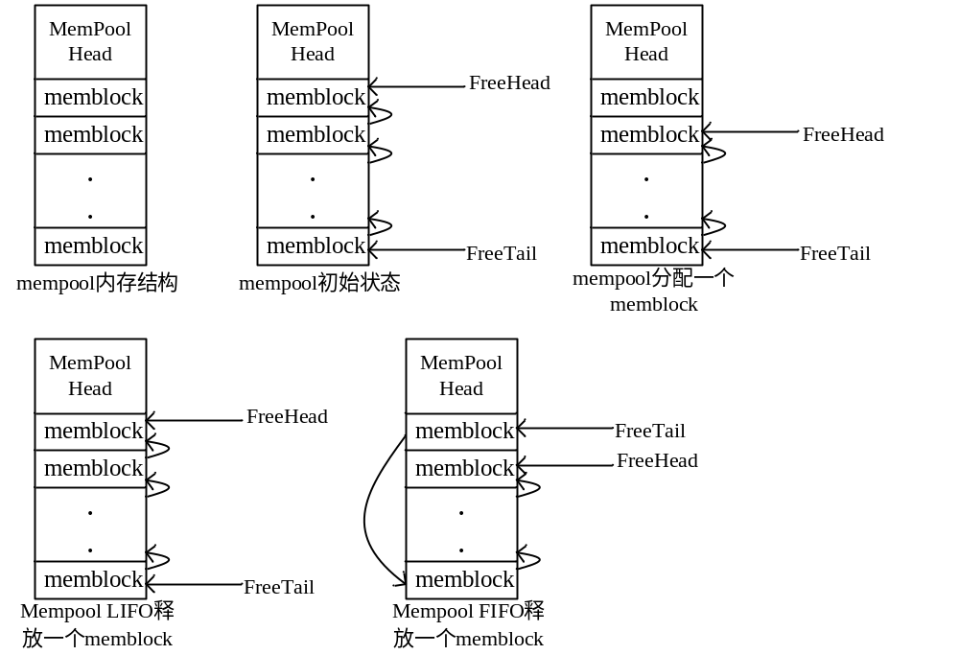
具体接口参见tmempool.h中的注释。

使用示例：
#include "comm/tmempool.h"

#define MAX_PLAYER_NUM 1000
typedef struct
{
int iIdx; /*idx in player mempool*/
int iLevel;
int iHP;
}Player;

int main(int argc, char* argv[])
{
int iRet;
int iIdx;
Player *pstPlayer;
TMEMPOOL *pstMemPool;

iRet = tmempool_new(&pstMemPool, MAX_PLAYER_NUM, sizeof(Player));
if (0 > iRet)
{
return -1;
}

//Player login , get a mempool
iIdx = tmempool_alloc(pstMemPool);
if (0 > iIdx)
{
Return -1;
}
pstPlayer = (Player *)tmempool_get(pstMemPool, iIdx);
if (NULL == pstPlayer)
{
return -1;
}
pstPlayer->iIdx = iIdx;
pstPlayer->iLevel = 1;
pstPlayer->iHP = 100;

//Player logout , free the mempool
tmempool_free(pstMemPool, pstPlayer->iIdx);

tmempool_destroy(&pstMemPool);

return 0;
}

tmempool_shm.h中的接口是共享内存中使用mempool的封装。

2.3 tini（读取配置文件）
假设一个world.cfg配置文件如下：
#config file for world_login process

MyEntityId = 1.0.21.1

BusConfigFile = /usr/local/mmog/bus/conf/world.bus
#Key For online_role , which is stored in SHM
KeyForOnline = 25000

MaxLoginPerSec = 100

ZoneID = 1, 3, 5

则读取配置的相应程序如下：
＃include "comm/tini.h"

#define MAX_ID 5

typedef struct {
int iMyEntityId ;
char szBusConfigFile[128] ;
int iKeyForOnline ;
int iMaxLoginPerSec ;
int aiZoneIDs[MAX_ID];
} WORLD_CONFIG;

int main(int argc, char* argv[])
{
WORLD_CONFIG stConfig;

TINITYPEDESC astConfigDesc[] = {
{"MyEntityId", TINI_IP, offsetof(WORLD_CONFIG, m_iMyEntityId)},
{"BusConfigFile", TINI_STRING, offsetof(WORLD_CONFIG, m_szBusConfigFile),"bus.ini" },
{"KeyForOnline", TINI_INT, offsetof(WORLD_CONFIG, m_iKeyForOnline)},
{"MaxLoginPerSec" , TINI_INT , offsetof(WORLD_CONFIG , m_iMaxLoginPerSec), "200" },
{"ZoneID" , TINI_INT_ARRAY , offsetof(WORLD_CONFIG, aiZoneIDs), "0", MAX_ID, ',' },
{""}
};

if (0 > tini_get_type("world.cfg", &stConfig, astConfigDesc))
{
return -1;
}

return 0;
}

假设一个配置文件test.ini配置文件如下：
[MetaBase]
Key=52001

[MetaLib]
LibName = roledb2

[App]
NewBus = 1
Bus = 9001
ID = 255.1.2.1
Log = ut_tormsvr
TormsvrID = 255.1.1.1
则读取配置的相应程序如下：
#define DEFAULT_METABASE_KEY "22001"
#define DEFAULT_BUS_KEY "1688"
#define DEFAULT_METALIB_NAME "roledb"
#define DEFAULT_EX_CFG "excfg.ini"
#define DEFAULT_BUS "tormsvr.bus"
#define DEFAULT_ID "1.0.92.1"
#define DEFAULT_LOG "ex_tormsvr"
#define DEFAULT_TORMSVR_ID "1.0.97.1"
#define DEFAULT_NEWBUS "1"

typedef struct tagTUtOrmSvrCfg
{
char szMetabaseKey[MAX_CFG_KEY];
char szMetaLibName[MAX_CFG_KEY];
char szProtoLibName[MAX_CFG_KEY];
char szID[MAX_CFG_KEY];
char szTormsvrID[MAX_CFG_KEY];
char szNewBus[MAX_CFG_KEY];
char szBus[MAX_CFG_KEY];
char szLog[MAX_CFG_KEY];
char szBusKey[MAX_CFG_KEY];
} TUTORMSVRCFG;

int get_test_cfg(char* pszCfgFile, TUTORMSVRCFG *pstCfg)
{
int iRet;

iRet = tini_read (pszCfgFile, "MetaBase", "Key", pstCfg->szMetabaseKey, sizeof(pstCfg->szMetabaseKey));
if (0 > iRet)
strcpy(pstCfg->szMetabaseKey, DEFAULT_METABASE_KEY);

iRet = tini_read (pszCfgFile, "MetaLib", "LibName", pstCfg->szMetaLibName, sizeof(pstCfg->szMetaLibName));
if (0 > iRet)
strcpy(pstCfg->szMetaLibName, DEFAULT_METALIB_NAME);

iRet = tini_read (pszCfgFile, "App", "NewBus", pstCfg->szNewBus, sizeof(pstCfg->szNewBus));
if (0 > iRet)
strcpy(pstCfg->szNewBus, DEFAULT_NEWBUS);

iRet = tini_read (pszCfgFile, "App", "Bus", pstCfg->szBus, sizeof(pstCfg->szBus));
if (0 > iRet)
strcpy(pstCfg->szBus, DEFAULT_BUS);

iRet = tini_read (pszCfgFile, "App", "ID", pstCfg->szID, sizeof(pstCfg->szID));
if (0 > iRet)
strcpy(pstCfg->szID, DEFAULT_ID);

iRet = tini_read (pszCfgFile, "App", "Log", pstCfg->szLog, sizeof(pstCfg->szLog));
if (0 > iRet)
strcpy(pstCfg->szLog, DEFAULT_LOG);

iRet = tini_read (pszCfgFile, "App", "TormsvrID", pstCfg->szTormsvrID, sizeof(pstCfg->szTormsvrID));
if (0 > iRet)
strcpy(pstCfg->szTormsvrID, DEFAULT_TORMSVR_ID);

iRet = tini_read (pszCfgFile, "App", "BusKey", pstCfg->szBusKey, sizeof(pstCfg->szBusKey));
if (0 > iRet)
strcpy(pstCfg->szBusKey, DEFAULT_BUS_KEY);

return 0;
}

假设有一个配置文件dir_svr.cfg如下：
[COMMON]
ProcID = 0.0.4.1
BusConfig = dir.bus
ListenPort = 6628
ClusterName = 幻想北方大区
AgentID = 0.0.6.1

[BUSY_DEGREE]
Excellence = 5
Normal = 15
Busy = 35
Full = 50

则读取其的程序如下：
typedef struct {
int iProcId ;
char szBusCfgFile[128] ;
int iListenPort ;
char szClusterName[32] ; //大区名字
int iAgentID ;
} Common ;

typedef struct {
int iExcellence ;
int iNormal ;
int iBusy ;
int iFull ;
} BusyDegree ;

typedef struct {
Common stCommon ;
BusyDegree stBusy ;
} Config ;

#define CommonDesc \
{"ProcID", CFG_IP, offsetof(Common, iProcId) ,"0.0.0.0" },\
{"BusConfig", CFG_STRING, offsetof(Common, szBusCfgFile),"bus.ini" },\
{"ListenPort", CFG_INT, offsetof(Common, iListenPort),"6629" },\
{"ClusterName", CFG_STRING, offsetof(Common, szClusterName),"幻想 online" },\
{"AgentID", CFG_IP, offsetof(Common, iAgentID) ,"0.0.0.0" }

#define BusyDesc \
{"Excellence", CFG_INT, offsetof(BusyDegree, iExcellence) ,"20" },\
{"Normal", CFG_INT, offsetof(BusyDegree, iNormal),"50" },\
{"Busy", CFG_INT, offsetof(BusyDegree, iBusy),"70" },\
{"Full", CFG_INT, offsetof(BusyDegree, iFull),"90" }

int ReadConfig ( char *pszCfgPath, Config *pstConfig )
{
TINISECTIONDESC astCommonDesc[] = {
{"COMMON", TINI_SECTION, offsetof(Config, stCommon), { CommonDesc, }},
{"BUSY_DEGREE", TINI_SECTION, offsetof(Config, stBusy), { BusyDesc, }},
{""}
};

if (0 > tini_get_ini(pszCfgPath, pstConfig , astCommonDesc) )
{
return -1;
}

return 0;
}

